Team BitByBit
Architecture Design
Fazlul F, Eitan A, Joshua D, Fotios B, Moh P

Database Tables

Customer Table, Console Table, PC games Table, Accessories Table, Cart

Views
Log-In Page, Sign-In Page, Home Page, Accessories Page, Console Games Page, PC games Page,Shopping Cart, Checkout,

Controllers

User controller, Product controller, Cart controller, Order controller, Login/Register controller.

Design Considerations

Deliverables
- Languages: JavaScript, TypeScript, Python
- Frameworks: Django, React Native
- Libraries:
- Services/API’s: Steam WEB API, RAWG Database API, GOOGLE STUDIO AI API, OPEN AI API
- Package/Build Manager: NPX, NPM, PIP (Python package manager)

- Task Assignments:
- Fazlul – Backend, Database, LLM
- Moh – Frontend, AI
- Joshua – Back-end, Database, Cloud
- Fotios – Frontend,some Database
- Eitan - Frontend, some Backend

Views:
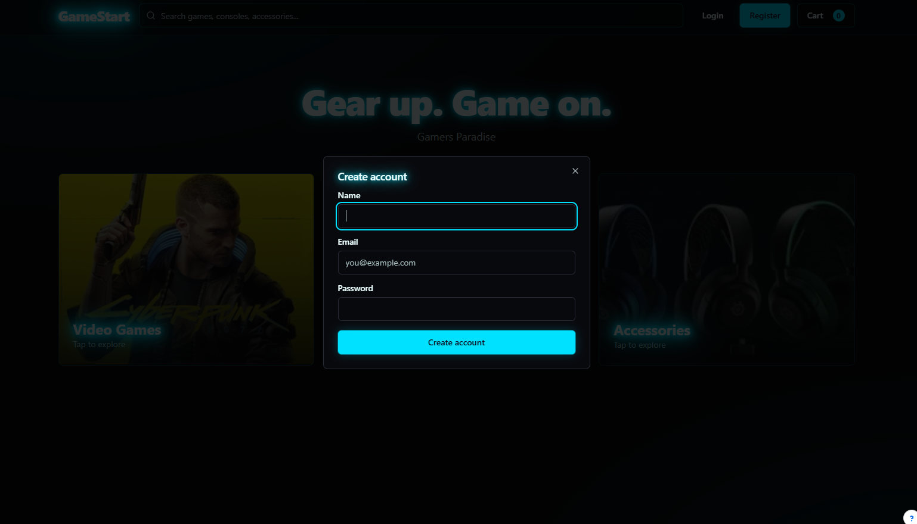
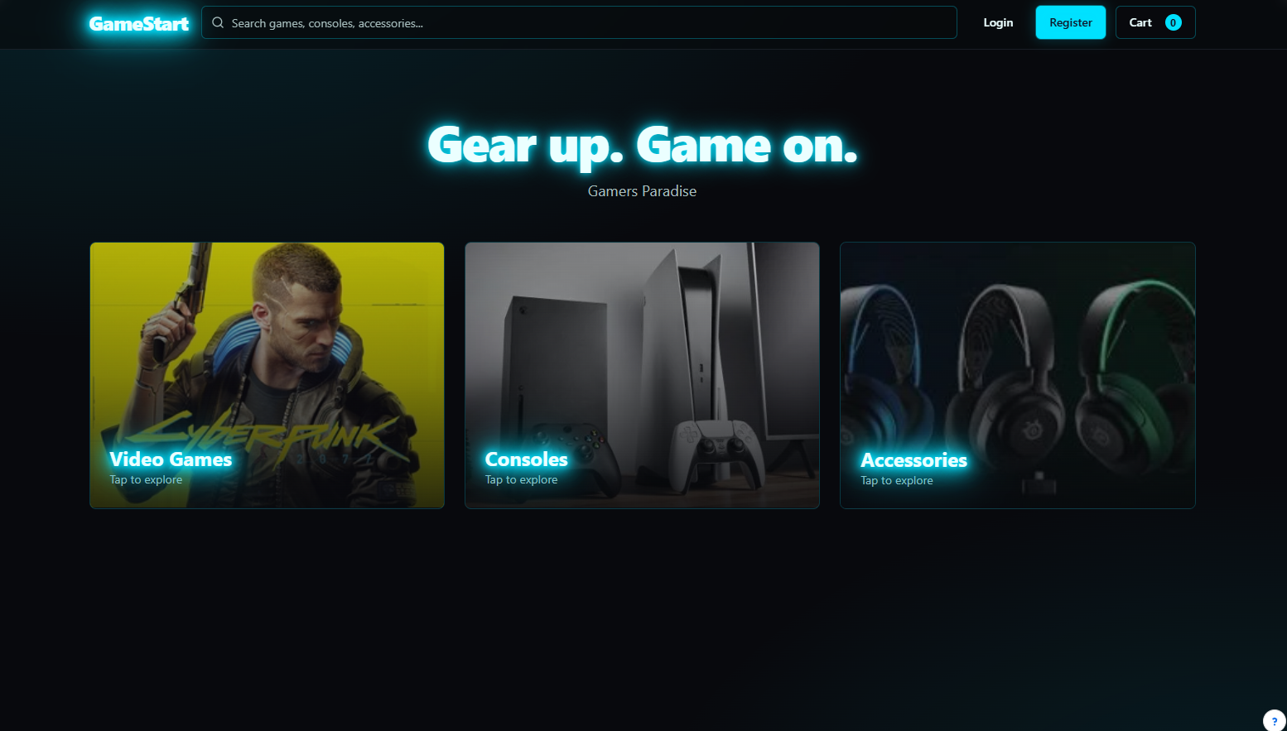

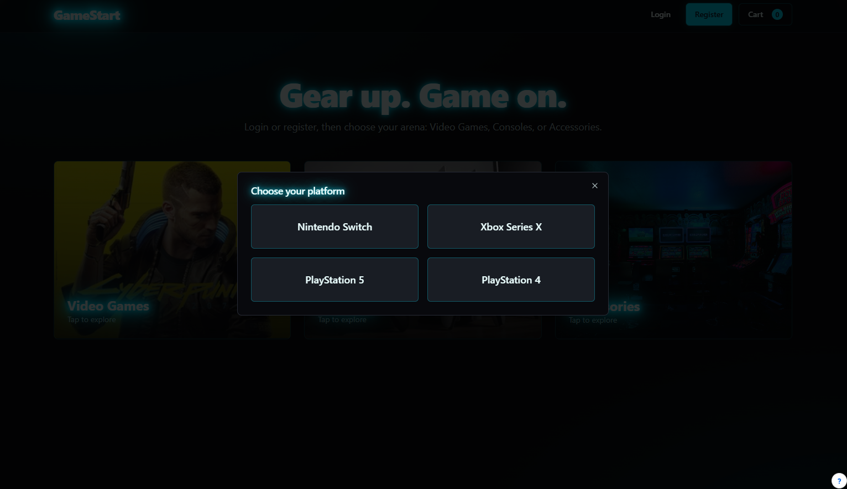
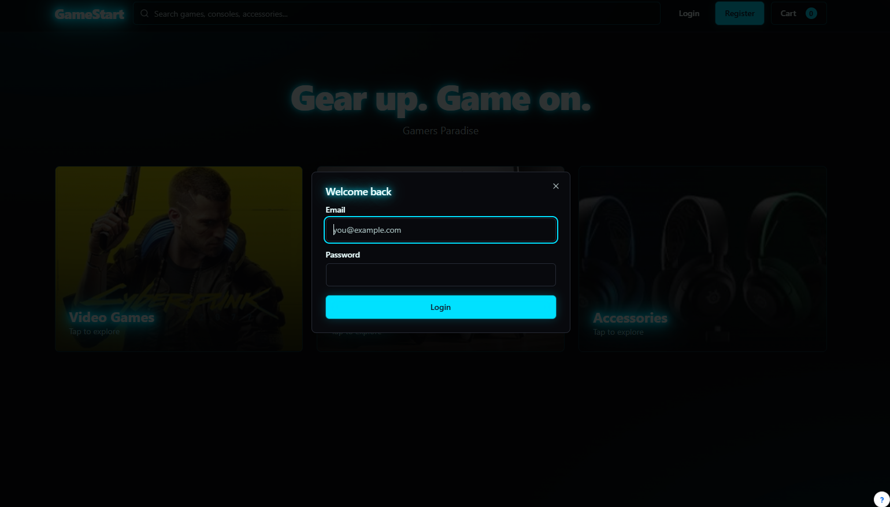
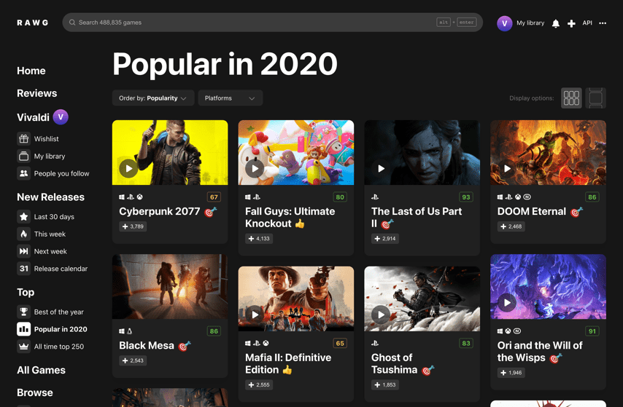
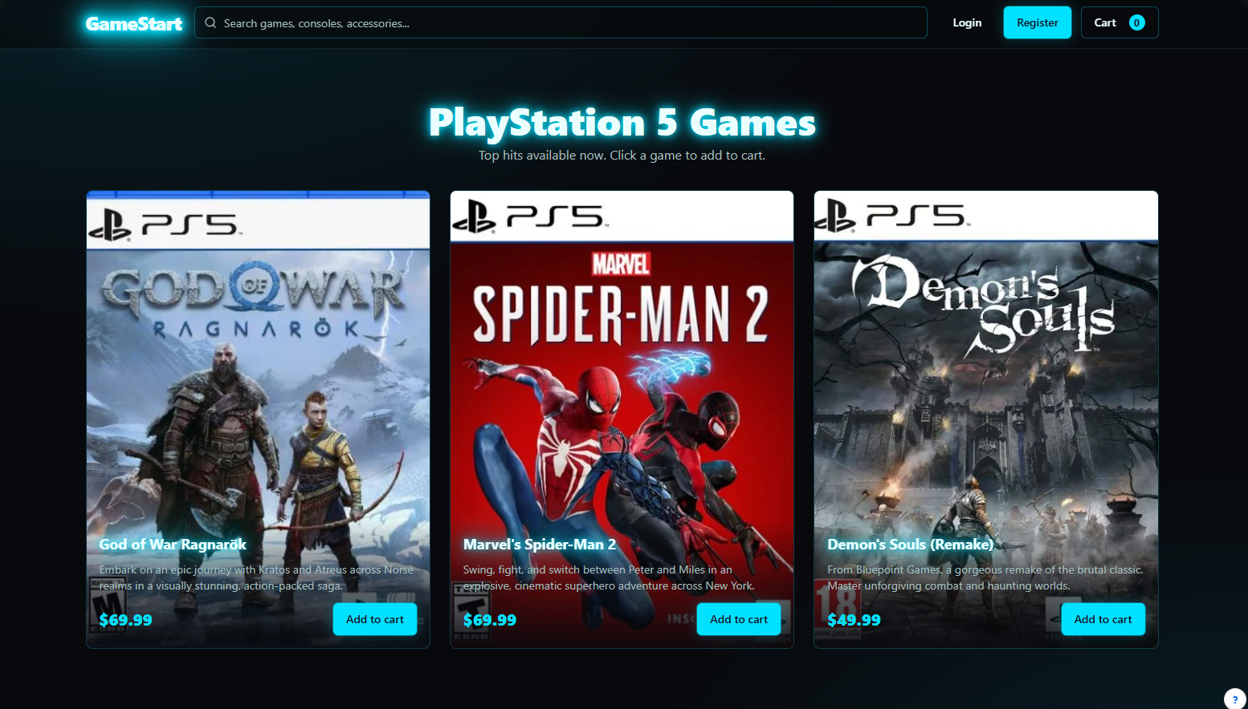

Database model

 | Field | Type | Description
User | UserID  Username  Role  Email  Password  Customer-Adress | int  String  String  String  String  String | Primarily key  User login name  Access control  Email address  Security code  Address deliver

 | Field | Type | Description
Products | Consoles  Games  Console-Joysticks  Merchandise  Product_Price | String  String  String  String  Double/Float | PS5/XBOX etc..  Video Games  Game Controllers  Shirts, posters, etc..  Individual product prices

 | Field | Type | Description
Cart | cartID  UserID  Quantity  productID | int  int,INT/String  Int  int,INT/String | Primarily key  Owner of cart  Amount chose  product

 | Field | Type | Description
Orders | orderID  userID  Price  Availability  orderDate | int  int  int/long  Boolean  String | Primarily key  Buyer  Cost  Availability  Time of purchase

